

|  |
| --- |
| **Collateral Management Garage** |
| Solution Design Document |



**Table of contents**

1 – Journey Overview and Prioritization 4

1.1 Basic Terms 4

1.2 Clearing Members 4

1.3 Collateral Maintenance 4

1.4 Collateral Management Processes 5

1.4.1 Collateral Acceptance 5

1.4.2 Collateral Valuation 7

1.4.3 Collateral Transfer 7

1.4.4 Collateral Release 7

1.5 Margins and Violations 7

1.6 High Level Area with Scope of Improvement 8

1.6.1 Client level monitoring of securities accepted as collateral (Pledge-Repledge Process) 8

1.6.2 Multiple Discrete Applications with related views 8

1.6.3 Collateral Addition, Release and Transfer Process 10

1.6.4 Collateral Usage 10

1.7 Opportunities Area Identified in Collateral Management: 10

1.8 Epics and Epic Description to Achieve Re-imagination 11

1.9 Microservices 17

2 - Collateral Management - Preferred Reality Technology 19

2.1 Design Constraint & Dependencies & Assumptions 19

2.1.1 Design Constraints 19

2.1.2 Dependencies 19

2.1.3 Assumptions 19

2.2 Identified Risk and Mitigation 19

2.3 Key Non-functional Requirements 19

2.4 Technology components 20

2.4.1. List of Technology Components 20

2.4.2. Technology Components Design 20

2.4.3. UI Component 20

2.4.4. API Gateway 21

2.4.5. Micro Services 21

2.4.6. Message Bus 21

2.4.7. Event Bus 21

2.4.8. Database 21

Common Platform Services 21

2.5 Technical Feasibility 21

2.6 Micro services 22

2.7 Data Architecture 24

2.7.1 Data Model 24

2.7.2 Data Migration 24

2.8 Object Model 25

2.8.1 Domain Object Model 25

2.8.2 Common Object Model 25

2.9 Data Validations 25

2.10 Business Rules 25

2.11 Sequence Diagrams for Key Business Process Flows of the Journeys 25

2.11.1 Release Securities via File upload and GUI 25

2.12 Logging 25

2.13 Error and Exception Handling 26

2.13.2 Error and Exception Handling in UI 27

2.13.3 Error and Exception Handling in Micro Services 27

2.14 Auditing 28

*2.15* Caching 28

2.16 Integration Interfaces 28

2.16.1 Integration Flows 28

2.16.2 Interface List 29

2.17 APIs Exposed For API Channel Interface 29

2.18 Security Design 30

2.18.1 Transport Security 30

2.18.2 Data Security 30

2.18.3 Authentication 30

2.18.4 Authorization 30

# – Journey Overview and Prioritization

## Basic Terms

***Collateral:*** Deposits placed by Members with NSCCL to meet margin obligations and other deposit requirements.

***Position:*** The outstanding buy or sell quantity in an underlying security/ contract of a member, based on trades by its constituents/ clients.

***Margins:*** Amount of collateral to be placed by the clearing member with NSCCL, for outstanding open position of its constituent/ client, as determined by Risk management framework of NSCCL.

## Clearing Members

Clearing corporations are entities that novate the transactions executed on exchanges, becoming the central counterparty, i.e. the buyer for every seller and the seller for every buyer. Clearing corporations provide settlement guarantee for all transactions through prudent risk management, carry out settlement of funds and securities, and manage defaults if any. NSE Clearing is the largest clearing corporation in the securities market in India and is a subsidiary of NSE.

NSE Clearing clears and settles trades executed on not only NSE, but also other exchanges under interoperability arrangements (i.e. BSE Ltd and Metropolitan Stock Exchange Ltd. [MSE].). The trading members are members of exchanges and have rights to execute trades on their proprietary account and on behalf of their clients on the exchanges. The Clearing Members are members of clearing corporations who can clear and settle the trades executed on exchanges. Trading members must either take clearing membership of clearing corporations or enter into clearing arrangement with another clearing member. Thus, there are three categories of clearing members as follows:

|  |  |
| --- | --- |
| ***Self-clearing members*** | *Entities that are clearing as well as trading members but clear the trades of the same trading member firm.* |
| ***Clearing cum Trading members*** | *Entities that are clearing as well as trading members and clear the trades of the own trading member firm, as well as other trading member firms.* |
| ***Professional Clearing Members*** | *Entities that are only clearing members and provide clearing services to other trading member firms.* |

## Collateral Maintenance

The clearing members are required to deposit various financial assets (cash, fixed deposits, securities etc.) as collateral. The collateral is required to be deposited upfront, i.e. before entering the trades.

The clearing corporations’ value the collateral considering prudential norms, eligibility criteria, limits, and haircuts etc. and assign trading limits to the clearing members. The clearing members in turn assign limits to trading members clearing through them.

## Collateral Management Processes

The collateral life cycle processes comprise of acceptance, valuation, transfer and release of collateral.

***General Process Flow:***

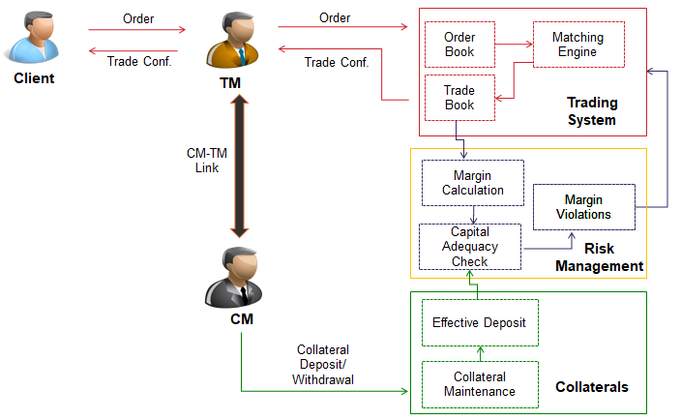

### Collateral Acceptance

NSE Clearing accepts multiple forms of financial assets as collateral; viz. cash, fixed deposits, bank guarantees, equity shares, mutual funds, government and corporate bonds etc. Members are required to provide liquid assets which adequately cover various margins and minimum Deposit requirements. A member may deposit liquid assets in various forms as prescribed by NSCCL from time to time.

|  |  |
| --- | --- |
| Cash form | Non-Cash form |
| Cash | Securities |
| Fixed deposit receipts | Units of Equity mutual funds |
| Bank Guarantees | Equity ETFs |
| Units of money market mutual fund | Gold ETFs |
| ETFs based on Government securities | Corporate Bonds |
| Government of India Securities/T-Bills | - |
| Foreign Sovereign Securities | - |

The general procedure for deposit of collateral in respect of different assets is as follows:

***Cash:*** Cash collateral is deposited through clearing banks (about 15) empaneled by NSE Clearing. Clearing members can maintain a clearing account with any bank for the purpose of settlement and may also maintain secondary bank accounts. The deposit of cash collateral can be through the settlement account or the secondary account. To provide cash as collateral, the members submit a deposit request through a web-based portal called Collateral Interface for Members (CIM). The respective banks confirm availability of funds on the NMASS portal, based on which the limit of the members is enhanced. The cash is then debited from the member’s account by sending necessary instructions to the bank.

Fixed Deposits: NSE clearing publishes the list of empaneled banks for issuance of bank guarantees (BGs) and fixed deposits (FDRs) towards collateral. There are about 58 banks that are empaneled for this purpose. There are two modes of deposit of FDRs –

1. The banks which issue a high number of FDRs use an API to submit the FDRs directly to NSE Clearing in an electronic form through the collateral interface for members (CIM). The electronic submission results in immediate increase in the trading limits without the member being required to submit the FDR in physical form. The online submission of FDRs through API is followed up by an end-of-day reconciliation with the issuing banks.
2. Other banks (typically ones which do not issue large number of collateral) provide FDRs in physical form to the clearing member. The clearing members submit such FDRs, along with necessary documentations at the regional offices of NSE across the country. The operations teams at regional offices verify the documentation and enter the FDRs in the system. The limits of members get enhanced after such entry.

***Bank Guarantees:***NSE clearing publishes the list of empaneled banks for issuance of bank guarantees (BGs) and fixed deposits (FDRs) towards collateral. There are about 58 banks that are empaneled for this purpose. Unlike FDRs, BGs are accepted only in physical form due to stamp duty constraints. The clearing members submit such BGs, along with necessary documentations at the regional offices of NSE across the country. The operations teams at regional offices verify the documentation and enter the BGs in the system. The limits of members get enhanced after such entry.

***Dematerialized Securities:***Securities are provided by members by way of marking a pledge in the depository system in favor of NSE Clearing. There are two ways of providing dematerialized securities to NSE Clearing.

1. Through empaneled custodians: NSE Clearing has empaneled custodians for the purpose of accepting securities as collateral. NSE Clearing maintains demat accounts with such custodians. Clearing members desirous of providing securities through empaneled custodians are required to open accounts with any custodian of their choice, transfer securities to such account and create a pledge in favor of NSE Clearing account maintained with the custodian.
2. Through any depository participant (DP): NSE Clearing has recently provided an additional facility to pledge securities through account maintained with any DP (many clearing members are DPs themselves.)

***Government Securities:***Government securities can be transferred to NSE Clearing through the RBI systems for providing such securities as collateral.

In the reimagined journey, the following process steps shall be followed for collateral addition.

|  |  |  |
| --- | --- | --- |
| Step # | Action | Notes |
| 1 | Received Master files from Core System at Start of the Day |  |
| 2 | Initiate the addition request from the GUI or via File Upload in the Parivartan system | File formats will remain same as per current implementation. The pledge-repledge for securities would have been implemented before Parivartan go-live |
| 3 | Perform technical and business validation as per the acceptance criteria in Parivartan | Master data information shall be required from NSE |
| 4 | If the validations fail, inform the user on the UI |  |
| 5 | Send the addition request to core system and assign a request id locally | The message structure shall remain the same as per current implementation |
| 6 | Receive the request from the core system | The message structure shall remain the same as per current implementation and the request- response shall be async |
| 7 | Inform the user based on the response and update local DB | In Sprint 2 and 3, alerts are out of scope. |

### Collateral Valuation

The collateral provided by clearing members is subject to multiple checks and prudential limits/rules. For example: limits on total amount of BG acceptable from member, from a given bank, or a bank-member combination, total quantity of each security acceptable from an individual level and overall market, haircuts applicable on the value of various collateral etc. These limits are published at relevant intervals through circulars.

The effective value of collateral is calculated by applying such norms/limits/haircuts to arrive at the effective value of the collateral.

In the reimagined journey, the collateral valuation would continue to be done in core system.

### Collateral Transfer

The collateral is required to be maintained separately for each segment. While depositing collateral, clearing members indicate the segment in which the collateral is to be added. The collateral in the form of cash, FDRs and fungible BGs (the BGs which are issued by bank generally and not in respect of a particular segment) can be transferred from one segment to another (e.g. from equity derivatives segment to currency derivatives segment).

The members can transfer collateral by placing a request in CIM. The collateral transfer is carried out automatically and immediately, provided that the remaining collateral in the original segment after such transfer is sufficient to meet margin requirements of the original segment.

In the reimagined journey, the following process steps shall be followed for collateral transfer.

|  |  |  |
| --- | --- | --- |
| Step # | Action | Notes |
| 1 | Received Master files from Core System at Start of the Day |  |
| 2 | Initiate the transfer request from the GUI or via File Upload in the Parivartan system | File formats will remain same as per current implementation. The pledge-repledge for securities would have been implemented before Parivartan go-live |
| 3 | Perform technical and business validation as per the acceptance criteria in Parivartan | Master data information shall be required from NSE |
| 4 | If the validations fail, inform the user on the UI |  |
| 5 | Send the addition request to core system and assign a request id locally | The message structure shall remain the same as per current implementation |
| 6 | Receive the request from the core system | The message structure shall remain the same as per current implementation and the request- response shall be async |
| 7 | Inform the user based on the response and update local DB | In Sprint 2 and 3, alerts are out of scope. |

### Collateral Release

The clearing members desirous of releasing their collateral can place a release request in CIM. The clearing members can indicate whether they wish to obtain the release immediately including during market hours, or on end-of-day basis or on a given value date (i.e. some date in future).

The collateral release is carried out after conducting checks regarding the remaining collateral after release being sufficient to meet the margin requirements. There are prioritization rules to decide which collateral is to be released in case multiple requests are placed by the member and the entire requested amount/quantity cannot be released.

In the reimagined journey, the following process steps shall be followed for collateral release.

|  |  |  |
| --- | --- | --- |
| Step # | Action | Notes |
| 1 | Received Master files from Core System at Start of the Day |  |
| 2 | Initiate the addition request from the GUI or via File Upload in the Parivartan system | File formats will remain same as per current implementation. The pledge-repledge for securities would have ben implemented before Parivartan go-live |
| 3 | Perform technical and business validation as per the acceptance criteria in Parivartan | Master data information shall be required from NSE |
| 4 | If the validations fail, inform the user on the UI |  |
| 5 | Send the addition request to core system and assign a request id locally | The message structure shall remain the same as per current implementation |
| 6 | Receive the request from the core system | The message structure shall remain the same as per current implementation and the request- response shall be async |
| 7 | Inform the user based on the response and update local DB | In Sprint 2 and 3, alerts are out of scope. |

## Margins and Violations

When trading members execute trades on the exchanges, such trades flow on a real-time basis to the risk management systems of the clearing corporations. The risk management systems calculate the margin requirement – which is a conservative estimate of probable loss on the position taken. The margin requirement should not exceed the effective valuation of the collateral deposited by the member. This check is done by the risk management system of the clearing corporation. In case of a margin violation, i.e. the effective value of the collateral deposited by the member being less than the risk-based margin requirement, the risk management system sends instructions to the trading systems of the exchanges to take appropriate risk-mitigating measures to control/limit the exposure towards such member.

***General Process Flow:***

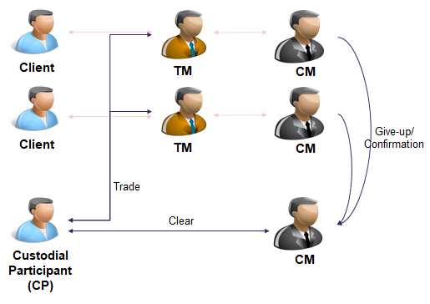

## High Level Area with Scope of Improvement

### Client level monitoring of securities accepted as collateral (Pledge-Repledge Process)

Under the current process, all forms of collateral are accepted directly from clearing members. The securities accepted as collateral are provided by the clearing members by way of pledge from the clearing member’s account to the designated account of NSE Clearing. NSE Clearing grants the benefit for such securities collateral at an overall basis to the clearing member and does not have visibility of whether the securities belong to the clearing member or any trading member/client availing the services of the clearing member.

With a view to curb potential wrongful utilization of client securities by clearing members by using such securities for any reason other than the obligation of the client providing such securities, it is proposed to do away with the transfer of securities from client account to the TM/CM account; and track the utilization of securities towards the margin obligation of respective clients at the clearing corporation.

### Multiple Discrete Applications with related views

* Some of the services are provided through thick client applications whereas others are web-based applications. All applications are one-size-fits-all basis.
* For offline file-based interface services are offered through EXTRANET application
* Interactive requests receipt from the clearing members is currently through batch mode i.e. file upload function on NCL provided application(s).
* Interfaces with the depositories are file based and, on the network,/ infrastructure/ applications as per guidelines issued by the depositories
* Similarly, in MFSS, interface with RTA/ AMC are file based and the interaction is through portals provided by such RTA/ AMC
* Interface with the Clearing Banks is two pronged:
  + File based interface provided by NCL.
  + Realtime API based interaction on Secured Financial Messaging Services (SFMS) on INFINET network of RBI-IFTAS. The messages standards are called Indian Financial Network (IFN) which are based on ISO2020. NCL is desirous to shift all clearing banks on this interface with its file-based interface as a back-up.
* For collateral banks
  + Issuance of FD – This can be done either manually i.e. no interface requirement or through native API published by NCL
  + Issuance of BG – This is currently done manually only. However, there is industry wide efforts to make issuance of BG in electronic form.
  + Acceptance of BG and FD – Here three options are available viz.
    - NCL’s application interface to approve FD/ BG issues
    - Native API published by NCL
    - SFMS platform
* There is a regulatory requirement on all the MIIs to adopt international standard messaging formats
* All applications must be adhered to the internal guidelines of Enterprise Risk Management in terms of network security, data encryption, secured FTP (SFTP), 2FA etc.
* Some of the products such as CBRICS, EBP are not supported through this application.

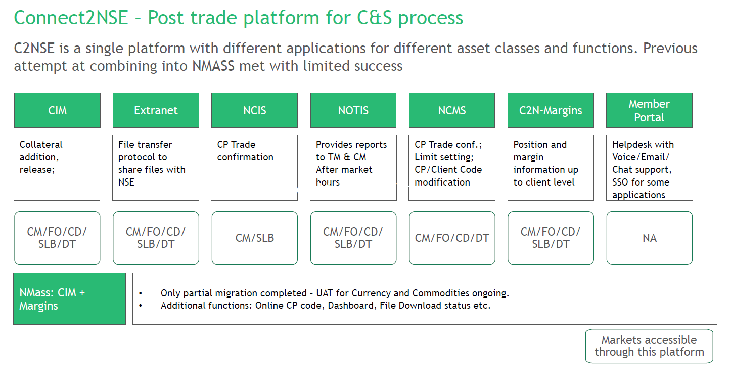

### Collateral Addition, Release and Transfer Process

* Transfer and Release request have a rigid cut-off
* Delays in collateral addition processes: Batch processing of security addition, manual data entry in physical FD/BG, only physical BG

### Collateral Usage

* Single instrument cannot be used across segments
* FD and BG must be transferred as a whole

## Opportunities Area Identified in Collateral Management:

* Operational Flexibility
* Flexible instrument allocation across segments
* Custom rule-based automation of collateral movement
* 'Anytime' facility for movement
* Faster Turnaround
* Straight Through Process
* Customized Integrated Platform
* Single application for all functions
* Custom alerts and proactive suggestions
* Customized real-time status dashboards

## Re-imagined Journey

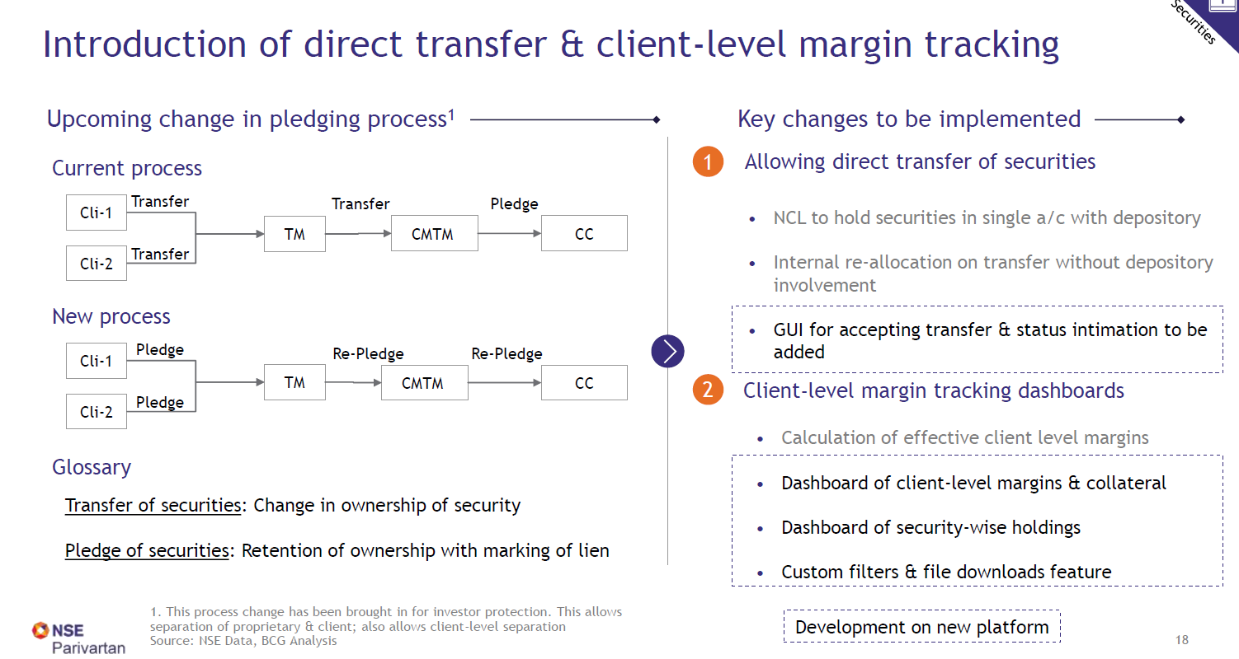

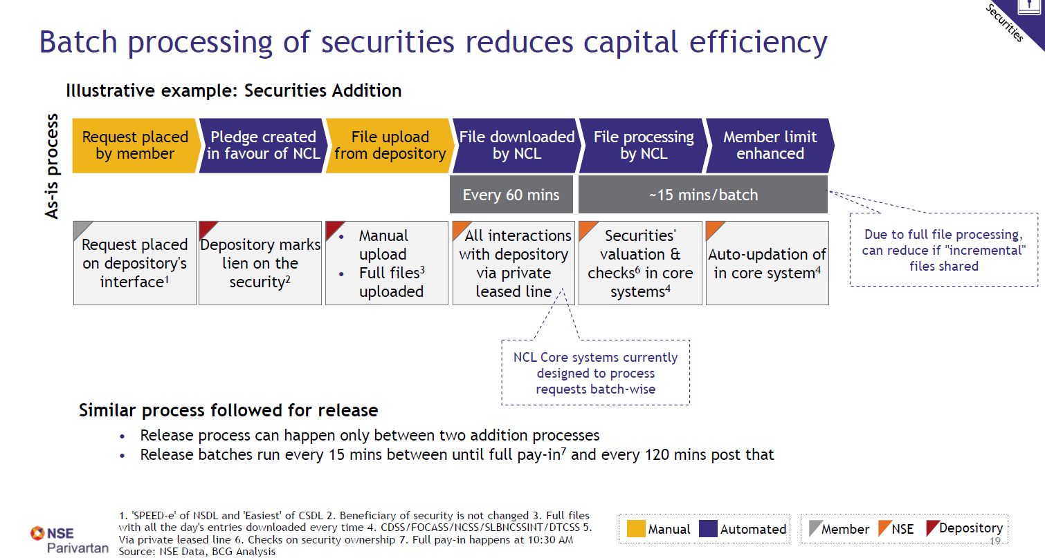

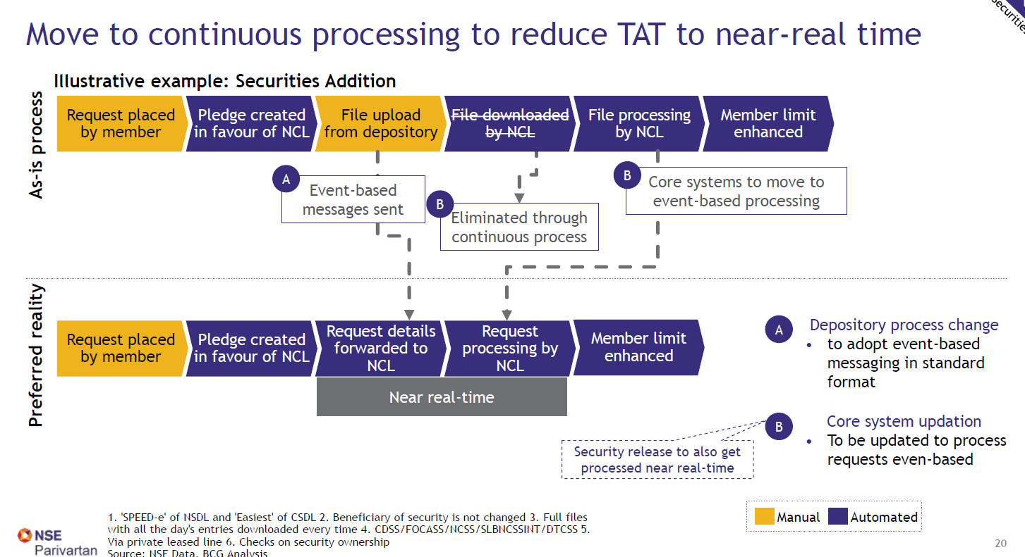

## Epics and Epic Description to Achieve Re-imagination

| **Sr. no.** | **Epic** | **Epic description** |
| --- | --- | --- |
| 1 | Addition of securities (for custodians) | File upload or GUI for segment addition request by custodian |
| Business & field validation checks  - Check uploaded files/GUI request for checking that all securities are marked to end client - prohibited securities & concentration limit checks- communication of violation to CM & Core System |
| Receiving updated margin details from Core system |
| Generation of alerts through file and GUI for successful/unsuccessful addition |
| 2 | Transfer securities | File upload for segment transfer request - perform fields validations & check against list of prohibited securities for a particular segment to show any error |
| GUI for segment transfer request - perform fields validations & check against list of prohibited securities for a particular segment to show any error |
| Internal handshake with core system to communicate transfer instruction |
| Status of request completion & revised utilisation to be pulled from core system |
| Generation of alerts through file and GUI for successful/unsuccessful transfer |
| 3 | Release securities | File upload or GUI for release request - perform field validations to show any missing fields |
| Internal handshake with core system to communicate release instruction |
| Status of request completion & revised utilisation to be pulled from core system |
| Generation of alerts through file and GUI for successful/unsuccessful release |
| 4 | Addition of physical FD/BG | Implementation of OCR - with focus on accuracy - measures to get maximum accuracy & address gaps if any i. Documents are autoscanned ii. OCR reads scanned documents and auto-inputs data in checklist |
| End-to-end integration (from data entry to entry of details in core system) - Workflow at the RO systems to be updated i. Home screen view for navigation to checklist or scanned documents etc.  ii. Checklist screen view (with auto-populated details) for checker confirmation iii. Details get exported to core system iv. Generation of alerts through file and GUI for successful/unsuccessful addition |
| 5 | Transfer FD/BG | For transfer of FDR & Fungible BGs: i. Screen views of FDR and BG transfer to be designed with borrowed fields from old platform and additional fields for part-transfer across segments ii. Internal handshake with core system & additional database layers (if any) to check capital adequacy, initiate transfer iii. Generation of alerts through file and GUI for successful/unsuccessful transfer |
| For NFBG transfer  i. Include a prominent flag indicating that this BG is non-transferrable to any other segment apart from the target segment ii. Screen flow to be designed such that it prompts member to provide necessary documents |
| 6 | Release of FD/BG ( to be migrated from existing systems) | File upload or GUI for release request |
| Internal handshake with core system to communicate release instruction & pull status of request completion |
| Generation of alerts through file and GUI for successful/unsuccessful release |
| 7 | Addition of cash | File upload or GUI for addition request |
| Debit note sent to bank for processing |
| Receive bank intimation of cash addition |
| Generation of alerts through file and GUI for successful/unsuccessful addition/transfer/release |
| 8 | Transfer + release of cash (to be migrated from existing systems) | File upload or GUI for release request |
| Internal handshake with core system to communicate release instruction & pull status of request completion |
| Generation of alerts through file and GUI for successful/unsuccessful transfer/release |
| 8 | Limit setting across Trading members ( to be migrated from existing systems) | Limit setting facility currently available in NCMS should be migrated to the new platform - facility should be accessible from beside TM margins views i. GUI for allocating limits across Trading members of a particular clearing member ii. Internal handshake with RMS to calculate capital adequacy at TM level against these limits iii. Generation of alerts through GUI for members going into risk reduction mode or disabled |
| 9 | Rule-based auto-collateral management | Customizable rule setting feature GUI set up:  i. options to add cash ii. Choose to segment,  iii. Trigger utilisation limit,  iv. target utilisation limit/ amount to be added v. collateral source (i.e. from where to add) |
| Tracking utilisation of the mentioned segment against trigger utilisation  i. Internal handshake with core system for margin & utilisation data ii. Monitor against the set limits for triggering automatic action of addition/release/transfer (as per set rule) |
| Calculate collateral to be added/released/transferred to reach target utilisation (if target utilisation option is chosen instead of amount to be added)  i. Calculate effective collateral required to reach target utilisation from trigger utilisation ii. Back calculate actual collateral (of particular asset type set in rules) that needs to be added basis effective collateral valuation rules & regulatory checks on prohibited securities & concentration limits etc. |
| Initiate action - as per the set rule when trigger utilisation is reached & as per value output from collateral to be added calculation |
| 10 | Anytime collateral allocation (with appropriate downtime) | 24*7 acceptance of addition/release/transfer requests - requests to be processed until NCL closes segment operations, post that store requests in queue for processing as soon as systems open up next day before trading starts |
| 11 | Securities collateral: Client-level Margin tracking dashboard | Create margin dashboard - needs to show client, TM, CM as filters and margin |
| Export feature in dashboard 1 for bulk file downloads |
| Securities wise dashboard - showing client, TM wise concentration in security |
| Export feature in dashboard 2 for bulk file downloads |
| Landing page of new platform screen view: With links to release, set file download location, client margin tracking dashboard & transfer |
| Screen for set file download location ( common for all platform downloads) |
| 12 | Non-securities collateral: Unified dashboard across segments | Showing margin utilisation across segments consolidated in one view. View to be customizable with option to choose from set of widgets |
| Consolidation of existing dashboards in new platform: Other dashboards like detailed collateral views, non-productive dashboards like client-margin reporting etc. to be migrated/redeveloped in new platform |
| List view of members in RR mode or disabled |
| Export feature for bulk file downloads |
| App-based view of the summary dashboards & related views as preferred |
| 13 | Filtering and dashboard setting | Creating custom filters based on TM, Client, Security, position, value |
| Setting of quick links/ preset filters |
| GUI to load filters for dashboard |
| 14 | Collateral Simulator | Collateral simulator to show effective collateral against current securities i. GUI/ file interface for member input ii. Importing data from core system on margin details etc.  iii. Coding the calculator basis rules of effective valuation (rules to get auto-updated monthly) |
| Effective collateral optimizer to show best combination of available securities i. GUI/file interface for member input ii. Importing data from core system regarding the current position against limits iii. Coding the calculator basis regulatory checks around prohibited securities & concentration limits |
| 15 | Alerts/ pop-ups | Customizable setting of required alerts on current utilisation & expiry - expiry alerts, low utilisation, high utilisation alerts etc. |
| SMS/ email alerts as per preferences |
| Margin benefit based suggestions: Eligible cross margin benefits |
| Margin benefit based suggestions: Nudges for full pay-in before 11 AM for margin exemption |
| Margin benefit based suggestions: Nudge towards adding particular items to their portfolio which can give them significant margin benefit (compliance angle to be given cognizance here) |
| Screen view: Record/ Log of all suggestions/alerts |
| 16 | Predictive suggestion pop-ups | Trading behavior based suggestive pop-ups - build/interface with ML engine to analyses trade behavior of the various TMs handled by the CM and suggest - predicted utilisation spike and nudge them to proactively add collateral - predict the margin spike due to expiry related position square-offs and nudge them to add collateral only for that specified time span |
| 17 | Database call-back feature | Even when the platform is undergoing maintenance/reboot, there should be database callback available for all segments so that members have 24*7 access to information |
| 18 | Dashboards for internal team | Dashboard tracking confirmations of successful extranet report downloads member-wise i. Intimation on successful report download ii. Intimation of report delivery error with details |
| Communication Dashboard -all communication with member to be recorded i. interface which allows to access, act and track and store member correspondence for future retrieval |
| 19 | Broker benchmarking tool/dashboard | Giving insight to members compared to benchmarks in terms of their operational efficiency i. Benchmarking engine at back end for KPIs - define metrics and benchmarks and create rules for calculations against given set of inputs ii. GUI for accepting trading member inputs against defined metrics iii. Back end calculations against benchmarks for relative performance views iv. Dashboard to display relative performance against peers |
| 20 | Defining user roles and rights - NCL (front end to be developed in clearing, ID creation specific to collateral etc. needs to be done here) | Admin profile possessing following functionalities:  1. Collateral access:  - ability to view/download all collateral statuses and reports 2. Member profile access: - ability to view and edit CM user profile (permissions for different segments) - ability to assign additional rights specific to a CM - ability to change # of users allowed for each CM - ability to enable/disable download limits for each CM |
| Audit profile possessing following functionalities: 1. Trade access: - ability to view download collateral statuses and reports |
| 21 | Defining user roles and rights - Clearing Members (front end to be developed in clearing, ID creation specific to collateral etc. needs to be done here) | Clearing Member admin profile possessing following functionalities:  1. User access:  ability to initiate collateral transfer, release requests ability to view collateral dashboards  2. Sub-user control: - ability to check/un-check login rights of their sub-users from a menu displaying all sub-users of the CM - ability to request for new sub-user profiles - ability to create a read-only profile |
| Clearing Member sub-users profiles possessing following functionalities: 1. User access: ability to initiate collateral transfer, release requests ability to view the collateral dashboards defined |
| 22 | Web-application platform (Discussion point only) (Taken up in clearing garage) | Compatibility to use on desktop and mobile browser |
| Ability to access on other browsers apart from Internet Explorer (Chrome, Edge, Safari, Firefox, Opera) |
| Cache to display login screen and existing dashboard |
| 23 | Setting up a User ID and rights assignment (Taken up in clearing garage) | Ability for ID generation platform to make edits to user credentials database |
| Creation of a secure database storing user credentials |
| Ability for member to make edits to their password in the credentials database only for their user ID |
| 24 | Signing-in to web platform using credentials (Taken up in clearing garage) | Preventing auto-fill of password on browsers of user systems to avoid misuse |
| Ability to input password using on-screen keyboard if they want to avoid keylogging |
| Ability to view different asset classes as tabs within same application (access provided basis user profiles created earlier itself) |
| Use single sign-on(SSO) for login |
| Switching between tabs would do an automatic re-sign in instead of asking for credentials again |
| 25 | Setting up multi-Factor authentication (one time tech discussion) (Taken up in clearing garage) | Different types of 2 factor authentication to be available basis member's system 1. Biometric 2. Okta push 3. SMS OTP/Mail OTP (Use backup codes in case OTP is not available or slow to obtain e.g. locations with bad network, jammers) 4. VPN |

## Microservices

| **Microservice** | **Description** |
| --- | --- |
| **Security Addition** | 1. The service will communicate with the core engine to send a security addition request at TM/CM/Client Level 2. The service will provide the revised utilization |
| **Security Transfer** | 1. The service will communicate with the core engine to send a security transfer request at TM/CM/Client Level 2. The service will provide the revised utilization |
| **Prohibited Security (Common service)** | 1. The service will take input the security detail and check whether the security is in prohibited list on not and respond accordingly |
| **Master Database Sync Up Service (Start of the Day)** | 1. The service shall sync up master files provided by Core system and required to be stored in local DB at Start of Day |
| **Alert Service (Platform Service)** | 1. The service will notify user based on response on success/failure by various methods. |
| **Security Release** | 1. The service will communicate with the core engine to send a security release request at TM/CM/Client Level 2. The service will provide the revised utilization |
| **Addition of Physical FD** | 1. The service shall update physical FD details in local DB upon receipt of message from core system. |
| **Addition of BG** | 1. The service shall update physical BG details in local DB upon receipt of message from core system. |
| **FD Transfer** | 1. The service will communicate with the core engine to send a transfer request of FD across segment in parts 2. The service will provide the revised utilization |
| **Fungible BG Transfer** | 1. The service will communicate with the core engine to send a transfer request of BG across segment in parts 2. The service will provide the revised utilization |
| **Cash Addition** | 1. The service will communicate with the core engine to send a cash addition request 2. The service will provide the revised utilization |
| **Cash Transfer** | 1. The service will communicate with the core engine to send a cash transfer request 2. The service will provide the revised utilization |
| **Cash Release** | 1. The service will communicate with the core engine to send a cash release request 2. The service will provide the revised utilization |
| **TM Limit** | 1. The service will be used to set Limit for TM 2. The service will be used to modify Limit for TM 3. The service will be used to remove Limits for TM 4. The service will be used to get Limit of TM 5. The receive will be used for sending the TM limit set by CM to the core system and process the response from core system. |
| **Rule Based Collateral Service** | 1. The service will be used to create rules based on the parameters set by user |
| **Collateral Rule Monitor Service** | 1. The service will monitor utilization against business rule post an event where there is margin utilization 2. It will validate the rule(s) and if the rule is with-in the criteria then it will trigger Cash Transfer Service |
| **CM Margin Limit** | 1. The service be used to get the CM Margin Limit and utilization |
| **TM Margin Limit** | 1. The service be used to get the TM Margin Limit under a CM and utilization |
| **Client Margin Limit** | 1. The service be used to get the Client Margin Limit under a CM +TM and utilization |
| **Margin Dashboard Service** | 1. The service will be used to render the dashboard based on output from the CM Margin Limit/TM Margin Limit/ Client Margin Limit |
| **Export** | 1. The service will be used to export data in a given format. |
| **User Configuration Service** | 1. The service will save the user preferences and will be invoked by the Export service. |
| **User Filter Setting** | 1. The service will store the user preferences on filters in the local DB |

# - Collateral Management - Preferred Reality Technology

## **Design Constraint & Dependencies & Assumptions**

### Design Constraints

### Dependencies

### Assumptions

## **Identified Risk and Mitigation**

## **Key Non-functional Requirements**

Refer to NSE Project Parivartan Digital Transformation Roadmap Document for Overall Key Non Functional Requirements defined.

## **Technology components**

### 2.4.1. List of Technology Components

|  |  |  |  |
| --- | --- | --- | --- |
| **Sr. No.** | **Area** | **Decision** | **Rationale** |
| 1 | Front end – web | **Angular** | Angular is better from a security perspective. It has better support for 12 factor coding standards. |
| 2 | Front end –mobile | **React Native** | Performance and user experience of React Native for mobile app development is better. |
| 3 | API Gateway | **Apigee** | Apigee is better from the code flexibility, OOB policy availability, etc. |
| 4 | Micro Services | **Springboot** | Springboot is a widely accepted Java development framework for microservices. It integrates well with other components. |
| 5 | Event Broker | **Kafka** |  |
| 6 | Cache | **Redis** | Redis is widely used. |
| 7 | Database - Structured data | **Oracle** | Pre-existing at NSE |
| 8 | SMS,OTP | **Vodafone OTP Server** | Pre-existing at NSE |
| 11 | SMTP Service | **Microsoft SMTP Server** | Pre-existing at NSE |

### 2.4.2. Technology Components Design

Front end is going to be developed using Visual Studio code and angular.

Microservices are build using REST API and spring boot framework standards. API will be developed using STS (Spring Tool Suit) Tool. Transactional data needs to be stored at New Interface, using Oracle DB .Junit will be the best practice to test build API.

### 2.4.3. UI Component

**Release Securities**

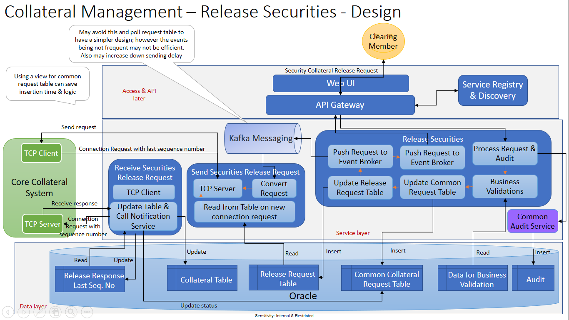

### 2.4.4. API Gateway

### 2.4.5. Micro Services

|  |  |  |
| --- | --- | --- |
| **S.No** | **Area** | **Comments** |
| 1 |  | Refer attached document for list of common components with various sections defined below   * Common Framework Components * Common Business Services * Cross Cutting Concerns |

### 2.4.6. Message Bus

### 2.4.7. Event Bus

Event-based communication could be establish when a microservice publishes an event when something notable happens, such as when it updates a business entity. Other microservices subscribe to those events. When a microservice receives an event, it can update its own business entities, which might lead to more events being published. This is the essence of the eventual consistency concept. This publish/subscribe system is usually performed by using an implementation of an event bus.

In current preferred reality during SOD all masters, Business rule tables present at new interface will be updated with the collateral management systems data, after that if we want to synch up the data from core system to the new interface we can implement event bus which will trigger an event whenever there is a changes in master data.

### Database

|  |  |  |  |
| --- | --- | --- | --- |
| **S.No** | **Area** | **Decision** | **Rationale** |
| 5 | Application Database – Structured | **Oracle** |  |

### Common Bussiness Services

#### Send OTP Notification

#### Send SMS Notification

#### SMTP Service

#### Email Service

|  |  |  |  |
| --- | --- | --- | --- |
| **S.No** | **Area** | **Decision** | **Comments** |
| 5 | Email Service | **InfoBip Provided APIs** | Setup and configure Email Template in Infobip Portal  Send Email by calling InfoBip APIs  <https://dev.infobip.com/#programmable-communications/email> |

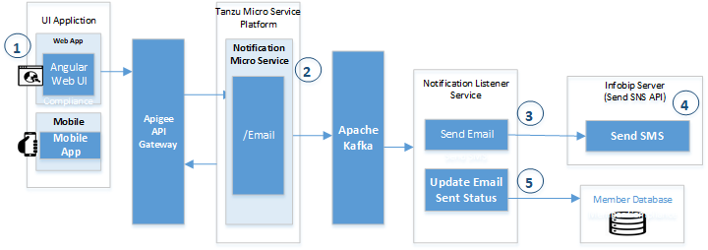

## **Technical Feasibility**

Tech feasibility assessment in-progress

|  |  |  |  |  |
| --- | --- | --- | --- | --- |
| *Sr. No.* | *Common Components* | *Applicable(Yes/No(* | *User Story(Optional)* | *Comments* |
|  | *Long Lived Business Process* |  |  |  |
|  | *Business Rules* | *Yes* |  |  |
|  | *Document Management* |  |  |  |
|  | *Scanning* |  |  |  |
|  | *Content Mgmt* |  |  |  |
|  | *OCR* | *Yes* |  |  |
|  | *Payments* |  |  |  |
|  | *SSO* | *Yes* |  |  |
|  | *2FA* | *Yes* |  |  |
|  | *Chatbot* |  |  |  |
|  | *Email* |  |  |  |
|  | *SMS* | *Yes* |  |  |
|  | *OTP* | *Yes* |  |  |
|  | *Push Notification* | *Yes* |  |  |
|  | *In-App Notification* | *Yes* |  |  |
|  | *Location Data Capture* |  |  |  |
|  | *AI/ML Use Cases* |  |  |  |
|  | *3rd party Integrations* |  |  |  |

## **Micro services**

#### List of Micro Services

##### Microservice and end point mapping

|  |  |  |  |  |  |
| --- | --- | --- | --- | --- | --- |
| *Sr.No.* | *User Story/Function* | *Swagger Path* | *Service Name* | *Service Description* | *Resource Endpoint* |
|  | Securities Release | https://collateralsecurities.apps.parivartandev1.com/swagger-ui.html | CollateralSecurityService | *security release request at TM/CM/Client Level* | /getReleaseSecurities  /saveReleaseSecurities  /validateReleaseSecuritiesRequest |
|  | Securities transfer | https://collateralsecurities.apps.parivartandev1.com/swagger-ui.html | CollateralSecurityService | *CM can transfer securities across segments* | /getTransferSecuritiesSummary  /validateTransferSecuritiesRequest  /saveTransferSecurities |
|  | Securities Addition |  | CollateralSecurityService | *This service is used to add security at TM/CM/Client Level* | /addSecurities |
|  | Addition of physical FD |  | AddPhysicalFDs Service | *The service shall update physical FD details in local DB upon receipt of message from core system.* | /addPhysicalFDs |
|  | Addition of BG |  | AddBGsService | *update physical BG details* | /addBGs |
|  | Transfer of FD |  | TransferFDsService | *transfer request of FD across segment in parts* | /transferFDs |
|  | Transfer BG |  | TransferBGsService | *send a transfer request of BG across segment in parts* | /transferBGs |
|  | Release of FD (to be migrated from existing system ) |  | ReleaseFDsService | *send a transfer request of BG across segment in parts* | /releaseFDs |
|  | Cash Addition |  | AddCashService | *This service is used for cash addition request* | /addCash |
|  | Cash Transfer |  | TransferCashService | *send a cash transfer request* | /transferCash |
|  | Cash Release |  | ReleaseCashServcie | *This service is used to send a cash release request* | /releaseCash |
|  | TM Limit |  | TMLimitServcie | *Set limit for TM* | /setLimitsForTradingMember |
|  | Home Dashboard and View Request status count | <https://collateralrequestsummary.apps.parivartandev1.com/swagger-ui.html> | collateralRequestSummaryService | *This service is used to View status and count details for request submitted for last 5 trading days and Request status check via file download* | /displayRequestStatusCount  /getRequestDetails  /downloadRequestDetails |

#### Common Platform Services

|  |  |  |  |  |  |
| --- | --- | --- | --- | --- | --- |
| *S.No* | *Common User Story/Function* | *Service Name* | *Service Description* | *Resource Endpoint* | *API Spec* |
| *2* | *Send OTP to subscribed mobile number* | *OTPlstformService* | *His platform service will receive message from Kafka and invoke Vodagone OTP Server to send message* | */sendOTP* |  |
| *3* | *Send SMS to registered Mobile umber* | *SMSPlatformServie* | *This platform service will receive will receive message from Kafka and invoke Vodafone Server to send single or Bulk SMS* | */SendSingleSMS*  */SendBulkSMS* |  |
| *4* | *Send Email to recipients* | *EmailService* | *This platform service will receive message from Kafka and send single of bulk email to email recipients* | */SendSingleEmail*  */SendBulkEmail* |  |

## **Data Architecture**

*<Cover the following points – What are the different data domain models for these microservices? Which databases will be implemented? What are the key data entities and relationships for microservices?>*

### Data Model

*<Cover the following points – Database Objects Design and Table Schema for the Journey should be explained here. This will be called Target Application Database Design>*

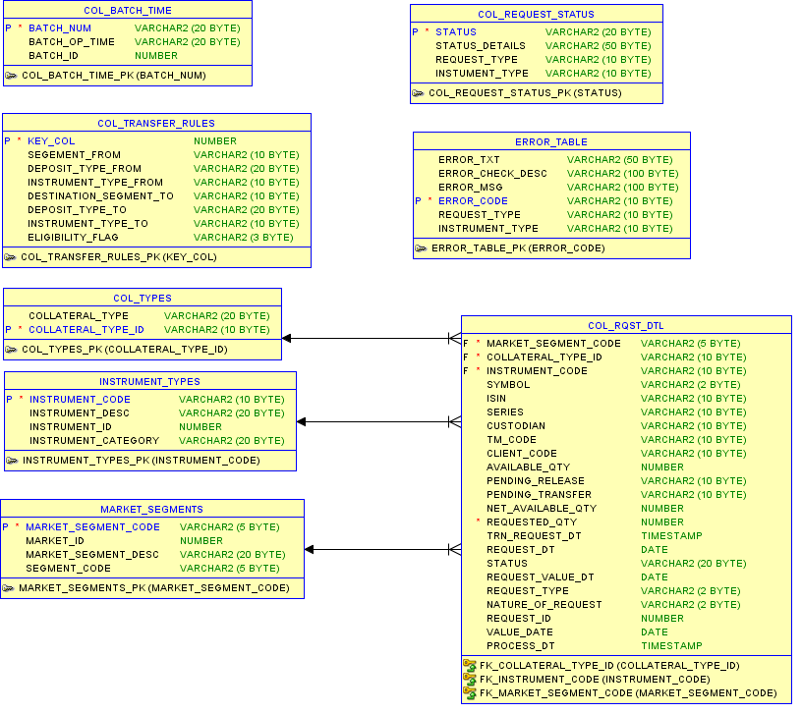

### Data Migration

*<Cover the following points – Database names, Schema and Tables of the Existing Applications which need to be migrated to the Target Application Database Schema/Objects. Specify the table/column mappings details etc. Also specify the file format in which existing application team to prepare the extract. >*

## **Object Model**

*<Cover the following points – For each of the microservice - Which are the different objects? What are the different attributes and associated functionalities and relationships with other objects within the microservice and outside?>*

### Domain Object Model

### Common Object Model

## **Data Validations**

*<Cover the following points – Refer user story/Epic Functional Flow output of Garage and specify data validations design>*

## **Business Rules**

#### Business validations are same listed in Business Exception below

## **Sequence Diagrams for Key Business Process Flows of the Journeys**

*<Cover the following points – For the key process flows of this journey, how are the technical components (microservices/objects/other software components) across different architectural layers interacting with each other? >*

### Release Securities via File upload and GUI



**Work in progress**

## **Logging**

## **Error and Exception Handling**

#### System Exception

For Transfer securities, Release securities, addition of cash etc. are mainly done through either a file upload or GUI. File to be uploaded in pre-defined format with naming convention. File upload will fail in below scenarios and records will be discarded.

* Uploaded file is not in predefined format : File format error
* File with missing fields : Fields are missing
* File with wrong field format and value: Invalid Fields.

Input validations to be performed on each field entered in GUI such as min, max length, date formats, allowed date criteria, type of field (string, number etc.), mandatory, non-mandatory fields etc.

#### Business Exception

Business validations received are as follows:

|  |  |  |  |
| --- | --- | --- | --- |
| Business Flow | | Validations | Error messages |
| Securities Release | For each request need to check requested quantity is greater than available quantity from master database, against member code, TM code, Client code and ISIN combination.  **Net available quantity** = availableqty – (qty requested for security release and transfer with status ‘Pending’) | | Requested quantity cannot be greater than available quantity |
| Securities transfer | For each request need to check requested quantity is greater than available quantity from master database, against member code, TM code, Client code and ISIN combination.  **Net available quantity** = availableqty – (qty requested for security release and transfer with status ‘Pending’) | | Requested quantity cannot be greater than available quantity |
|  | Security ISIN and destination segment combination is eligible needs to Check in database against the list of eligible securities if the security ISIN is eligible in the destination segment. | | Security not eligible in destination segment |
|  | Segment and destination segment combination is not allowed. | | Transfer not allowed between specified segments |
|  | Check to be made in destination segment for Member that should be CM in destination segment. | | Transfer not allowed as member not a CM in destination segment |
|  | Check to be done on CM-TM link in destination segment for security transfer eligibility. | | Transfer not allowed as CM-TM link is missing in destination segment |

**Work in Progress**

#### ErrorCodes

Below are few HTTP status codes

|  |  |  |
| --- | --- | --- |
| Error Codes | Description | |
| 200 OK | | Successful requests other than creations and deletions. |
| 201 Created | | Successful creation of a queue, topic, temporary queue, temporary topic, session, producer, consumer, listener, queue browser, or message. |
| 204 No Content | | Successful deletion of a queue, topic, session, producer, or listener. |
| 400 Bad Request | | The path info doesn't have the right format, or a parameter or request body value doesn't have the right format, or a required parameter is missing, or values have the right format but are invalid in some way (for example, destination parameter does not exist, content is too big, or client ID is in use). |
| 403 Forbidden | | The invoker is not authorized to invoke the operation. |
| 404 Not Found | | The object referenced by the path does not exist. |

### Error and Exception Handling in UI

UI exceptions are mainly handled on observable contract using RxJs library.

**Work in progress**

### Error and Exception Handling in Micro Services

As Exception Handling is a cross-cutting concern better handled in dedicated code, the global @ExceptionHandler is to be used with the @ControllerAdvice annotation to throw business and technical related exceptions.

The @ControllerAdvice annotation allows to consolidate multiple @ExceptionHandlers into a single, global error handling component. That is, the @ControllerAdvice annotation provides a centralized place for the exceptions thrown from all of the Controllers.

This mechanism is simple but also very flexible. It provides:

* Full control over the body of the response as well as the status code
* Mapping of several exceptions to the same method, to be handled together, and
* It makes good use of the newer RESTful ResposeEntity response

Some of the possible exception handling scenarios are listed below.

When a validation fails, a meaningful error message is to be returned to the client in order to enable the client to display a helpful error message to the user. A data structure should be returned containing an error message for each validation that failed.

A global ControllerAdvice is created that handles all ConstraintViolationExceptions that bubble up to the controller level. In order to catch validation errors for request bodies as well, MethodArgumentNotValidExceptions are to be handled.

It is possible to combine different approaches within a single application. For example, implement a @ControllerAdvice globally, but also ResponseStatusExceptions locally. However, it needs to be considered with caution if the same exception is to be handled in multiple ways.

A possible convention is to handle one specific kind of exception always in one way.

For more details refer Common Cross Cutting Concerns Design for Logging

## **Auditing**

Refer Common Cross Cutting Concerns Design for Auditing

## **Caching**

Refer Common Cross Cutting Concerns Design for Caching

## **Integration Interfaces**

### Integration Flows

1. **Release / Transfer Securities :** We have AngularUI application which will be used by clearing member to release /transfer securities using file upload or GUI, post performing input validations at UI request is submitted to new application using the API which is exposed to UI.

All API’s mainly perform following below tasks

1. Perform server side validations on received inputs
2. Perform Business Validations

Post successful business validations request is submitted to core system in asynchronous communication. An intermediate response is given back to UI.

Request is then processed in Batch manner, new application will pull the status periodically and update the same in its ldb and share the status with UI.

### Interface List



## **APIs Exposed For API Channel Interface**

*<Cover the following points – Refer user story/Epic Functional Flow output of Garage and specify APIs exposed and its detailed end points signatures for consumption of stakeholders e.g. Trading Members, Clearing Members etc.>*

|  |  |
| --- | --- |
| API Description | Endpoint |
| Securities Release | /getReleaseSecurities  /saveReleaseSecurities  /validateReleaseSecuritiesRequest |
| Securities transfer | /getTransferSecuritiesSummary  /validateTransferSecuritiesRequest  /saveTransferSecurities |
| Securities Addition | /addSecurities |
| Addition of physical FD | /addPhysicalFDs |
| Addition of BG | /addBGs |
| Transfer FD | /transferFDs |
| Transfer BG | /transferBGs |
| Release of FD (to be migrated from existing system ) | /releaseFDs |
| Release BG (to be migrated from existing system) | /releaseBGs |
| Addition of cash | /addCash |
| Transfer of cash (to be migrated from existing system) | /transferCash |
| Release of cash (to be migrated from existing system) | /releaseCash |
| Limit setting across Trading members ( to be migrated from existing systems) | /setLimitsForTradingMember |
| Securities collateral: Client-level Margin tracking dashboard | /createClientLevelMarginDashboards |
| Request status check | /displayRequestStatusCount  /getRequestDetails  /downloadRequestDetails |

## **Security Design**

**Discussion in progress and to be finalized. Update this section later.**

### Transport Security

### Data Security

**How to secure data with encryption, vormetric, tool usage, data masking etc..**

### Authentication

#### Authentication for Web

#### Authentication for API Gateway

#### Authentication for Micro Services

### Authorization

#### Authorization for Web

#### Authorization for API Gateway

#### Authorization for Micro Services